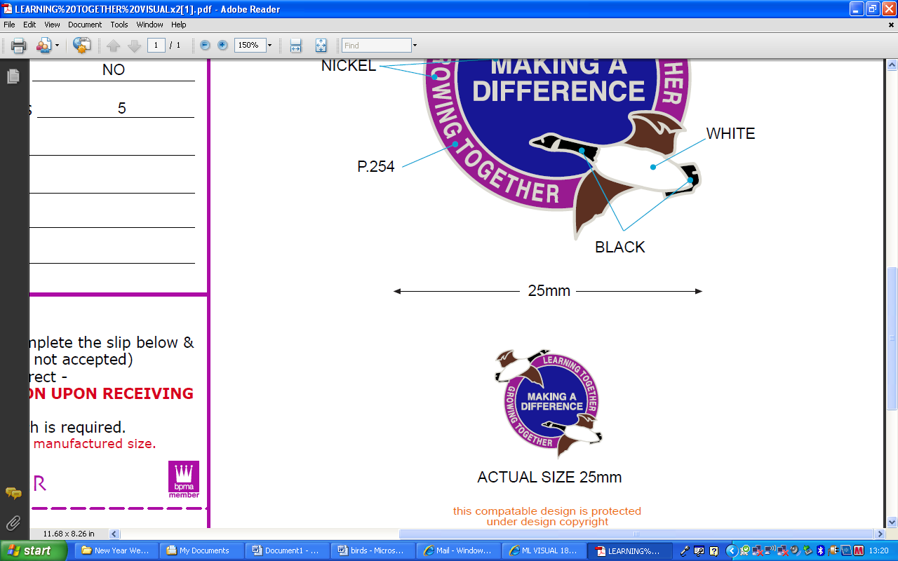

Brambles Primary Academy

Background Information

Our Academy was recognised as outstanding by Ofsted (February 2019) “As a result of focused, very effective teaching and timely interventions and support, pupils’ outcomes have improved year on year.

At Brambles Primary Academy, our motto is simply ‘Learning together; growing together; making a difference’. This embodies our belief that, as part of the Tees Valley Education Trust, we aim to develop a community of learners who through the use of dynamic teaching and learning, committed collaboration and a consistent drive for progress, all achieve their full potential. We aim to recruit staff of the highest quality so we are able to consolidate, challenge and constantly improve the quality of the education we provide for the 300 plus children on roll, including our nursery provision.

[](http://brambles.teesvalleyeducation.co.uk/wp-content/uploads/sites/2/nggallery/brambles-primary-academy-2016/Brambles-100.jpg)

We are very proud of our Academy and our Trust and are delighted to serve the community of Brambles Farm in East Middlesbrough. As a Trust, we are on an incredibly exciting journey with our partner academies Pennyman Primary Academy, Dormanstown Primary Academy, Discovery Special Academy and Wilton Primary Academy to work collaboratively to ensure the best outcomes for all of our learners and staff. Whilst our context is challenging (around 25% of children have Special Educational Needs and 73% of our pupils are eligible for pupil premium) we believe it is our responsibility to support our children with their life chances, opportunities and employability. The academy consists of 3 phases; Early Years Foundation Stage, Key Stage 1 and Key Stage 2. With the exception on Nursery, each year group is two- form entry, with an admission number of approximately 45 per year. Within each year group there are Learning Support Assistants to meet the varying needs of all our children. Our inclusive ethos and well-established system of pastoral care allows us to integrate our children as much as possible, and has created a nurturing environment that enables children to be successful, confident learners.

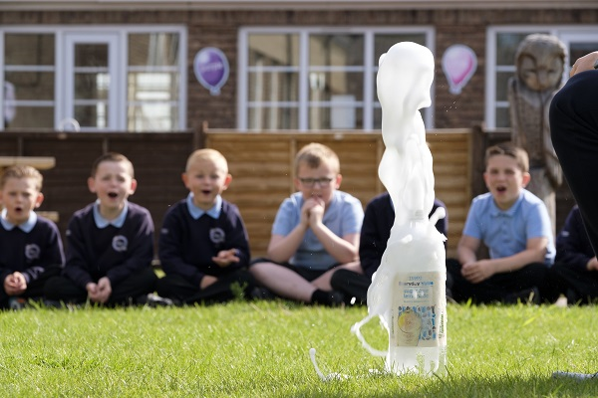

[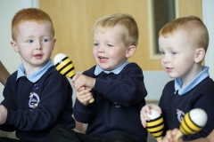](http://brambles.teesvalleyeducation.co.uk/wp-content/uploads/sites/2/nggallery/brambles-primary-academy-2016/Brambles-25.jpg)

We are incredibly proud of our achievements at Brambles and the opportunities offered to everyone within our academy. We are dedicated to making a difference to the lives of the children in our care. Consequently, we are continually looking for talented, dynamic and committed individuals to join and contribute to our hard-working team.

We look forward to welcoming you to our team

Mr Darren Higgins

**Acting Head Teacher**